**What is MPMS?**

MPMS or Multi-Package Management System consists of 4 major classifications or features; Client Management System, Agency Management System, Service Management System, and System Management. Each classification will have a mockup user interfaces design that will be presented in this document.

**MPMS Login Page**

Figure 1 shows the login page which allows a user to gain access to MPMS by entering their username and password. There are three different users of this system and each user will have different functions in the system. Here’s the list of the users that can login to MPMS:

* Application Admin/Operator
* Sales Personnel
* Service Personnel

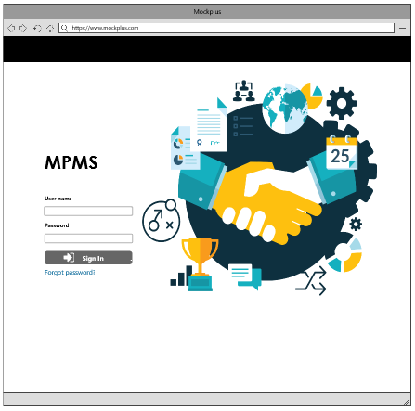

Figure 1. MPMS Login Page

**Account Recovery**

* If the user forgot his/her Password, there will be a forgot password link below the sign in button (see figure 1), wherein the user will be redirected to a page to recover the account. As shown in Figure 2a, the user must enter the email to search his/her account.

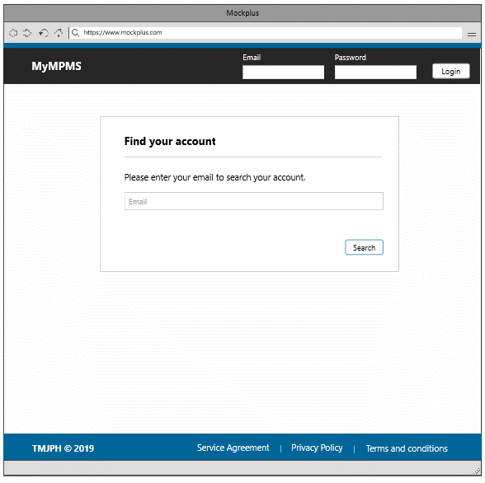

Figure 2a. Find account

* After the user has find his/her account, there will be a confirmation section wherein the user needs to verify. The reset account link will be submitted to the user email account.

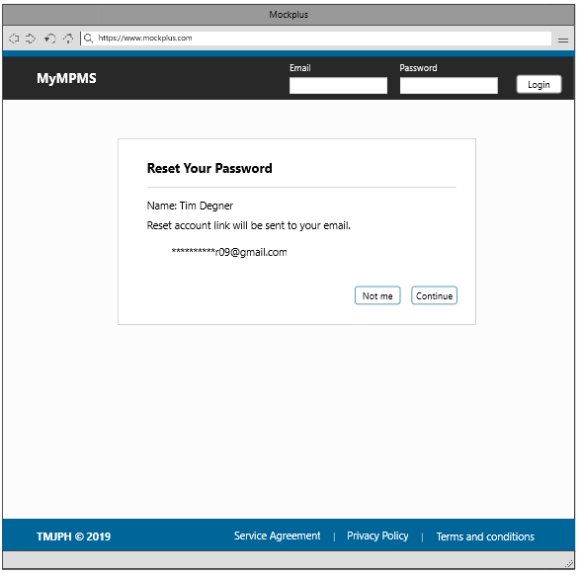

Figure 2b. Reset Account Link

**Admin Landing Page**

The admin has the capability to view everything in the system, such as the lists of clients, contracts, services, pricing, authorization, agencies and users of the system. The admin also has the capability to create a new agency information, user information and handles security settings which will later be shown in this documentation.